**.NET Application Programming**

**Project Status and Design Report**

|  |  |  |
| --- | --- | --- |
| **Topic:** | *CLC Milestone 1: Initial Scrum Planning* | |
| **Date:** | *9/2/2018* | |
| **Revision:** | *1.0* | |
| **Team:** | 1. *Michael Weaver* | |
| 1. *Mark Piland* | |
| 1. *Fredrick Ondieki* | |
|  | |
| **Weekly Team Status Summary:** | |  |  |  |  | | --- | --- | --- | --- | | **User Story** | **Team**  **Member** | **Hours**  **Worked** | **Hours Remaining** | | *Documentation* | *Michael* | *3* | *0* | | *Mockups* | *Fredrick* | *1* | *0* | | *Burndown Sheet* | *Mark* | *1* | *0* | | *Product BackLog* | *Team* | *1* | *0* | | *Sprint Log* | *Team* | *1* | *0* | |  |  |  |  | |  |  |  |  | |  |  |  |  | |  |  |  |  | |  |  |  |  | |  |  |  |  | |  |  |  |  | |  |  |  |  | | |
| **GIT URL:** | *https://github.com/battousairurik/CST-247* | |
| **Peer Review:** | *Y/N* | Yes |

**Planning Documentation**

**Agile Scrum Product Backlog:**

[*https://github.com/battousairurik/CST-247/blob/master/Week%201/Project%20Backlog.xls*](https://github.com/battousairurik/CST-247/blob/master/Week%201/Project%20Backlog.xls)

**Agile Scrum Sprint Backlog:**

[*https://github.com/battousairurik/CST-247/blob/master/Week%201/Sprint%20Product%20Log.xlsx*](https://github.com/battousairurik/CST-247/blob/master/Week%201/Sprint%20Product%20Log.xlsx)

**Agile Scrum Burn Down Chart:**

[*https://github.com/battousairurik/CST-247/blob/master/Week%201/Burndown%20Sheet.xlsx*](https://github.com/battousairurik/CST-247/blob/master/Week%201/Burndown%20Sheet.xlsx)

**Agile Retrospective Results:**

*The following table should be completed after each Retrospective on Things That Went Well (Keep Doing). An alternative to the following table is to use a Mind Mapping tool such as Coggle. If you use a Mind Mapping tool you must include a URL or Image File.*

|  |
| --- |
| **What Went Well** |
| **Group meeting went well, brainstorming was successful in ensuring the group is on the same page and all work is successfully outlined.** |
|  |
|  |

*The following table should be completed after each Retrospective on Things That Didn’t Go Well (Stop Doing) and What Would Be Done Differently Next Time with an Action Plan to Improve (Try Doing and Continuous Improvement). An alternative to the following table is to use a Mind Mapping tool such as Coggle. If you use a Mind Mapping tool you must include a URL or Image File.*

|  |  |  |
| --- | --- | --- |
| **What Did Not Go Well** | **Action Plan** | **Due Date** |
| **Meeting late in the week** | **Meet twice each week** | **N/A** |
| **Documentation took longer than expected and was more in depth than expected.** | **Have team assist with Documentation.** | **N/A** |
|  |  |  |

**Design Documentation**

**Install Instructions:**

*Step by step instructions for setting up your database, configuring, and deploying/installing your application. This section should also include detailed instructions for what configuration files are required by your application, what configuration settings need to be adjusted for various runtime (development or production) environments, and where the files need to be deployed to. This section should also contain detailed instructions for how to clone your application source code from BitBucket and deploy the application to an externally hosted site.*

*Retrieve Project from GitHub*

*Follow the included link in this documentation to the BitBucket account.*

*Preferably clone the entire repository.*

*Open the Minesweeper folder. Click on the executable file (Minesweeper.exe – Shortcut)*

*Retrieve Code from GitHub*

*Follow the included link in this documentation to the BitBucket account.*

*Within Repository, open the Minesweeper Folder.*

*Open Minesweeper Project folder.*

*Retrieve necessary source code.*

**General Technical Approach:**

*You should, in words, describe your approach and design here. You should also summarize any meeting notes, brainstorming sessions, etc. that you want to retain thru the design of your project.*

This Week consisted of uploading the preexisting project to the team repository, followed by a team meeting and generation of user stories for future work. The goal of this week was to update each team member with the goals and expectations of this class and ensure that all future work can be accomplished in a timely manner.

**Key Technical Design Decisions:**

*Any final technical design decisions, such as framework decisions, etc., should be documented here. This should list the technology/framework, its purpose in the design, and why it was chosen.*

Section Currently Not Applicable.

**ER Diagram:**

*Image file of your ER database diagram.*

Section Currently Not Applicable.

Project currently uses a text file to store game data and has not yet been updated to include a database.

**DDL Scripts:**

*This should contain a link to BitBucket where the DDL script can be downloaded from.*

Section Currently Not Applicable.

There is currently no Database in use and therefor no DDL Scripting, yet.

**Sitemap Diagram:**

*Image file of your Sitemap diagram.*

Section Currently Not Applicable.

There is currently no sitemap for the application because it does not use webpages. See Flowchart for game logic.

**Security Design:**

*This section should outline the design for how authentication and authorization was supported. This section should also contain all of the roles and privileges that are supported by the design.*

Section Currently Not Applicable.

Authentication is currently not applicable in version 1.0.

**Third Part Interface Design:**

*This section should fully document any Third Party Service Interface API’s, how to access the service, what parameters are required by the API, and the detailed JSON data format specification that could be used by a third party developer to integrate with the service and API.*

Section Currently Not Applicable.

No third party material is currently used in version 1.0.

**Flow Charts:**

*You should insert any flow charts here. Flow charts should document algorithms or workflow that will be implemented in your program. At a minimum this should contain a flow chart of the Minesweeper game logic.*

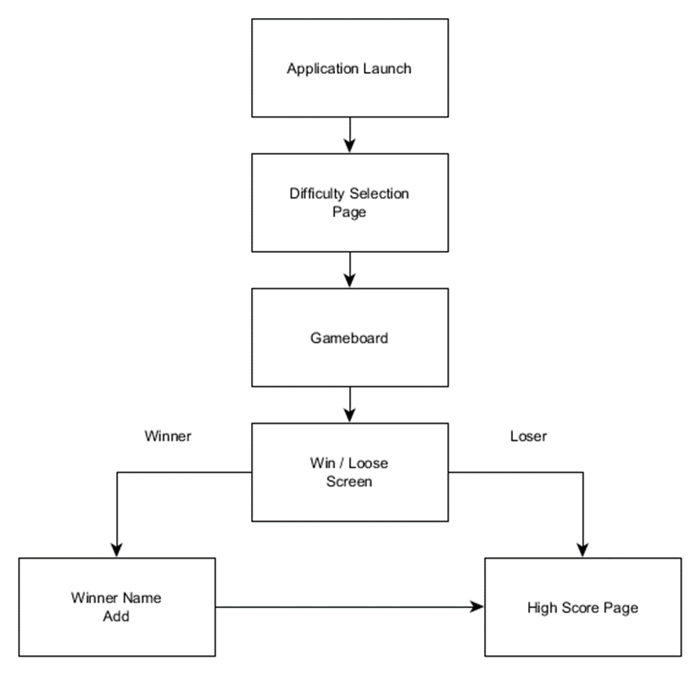

**User Interface Diagrams:**

*You should insert any wireframe drawings or white board concepts that were developed to support your application. If you have no supporting documentation please explain the rational why you are able to leave this section as N/A.*

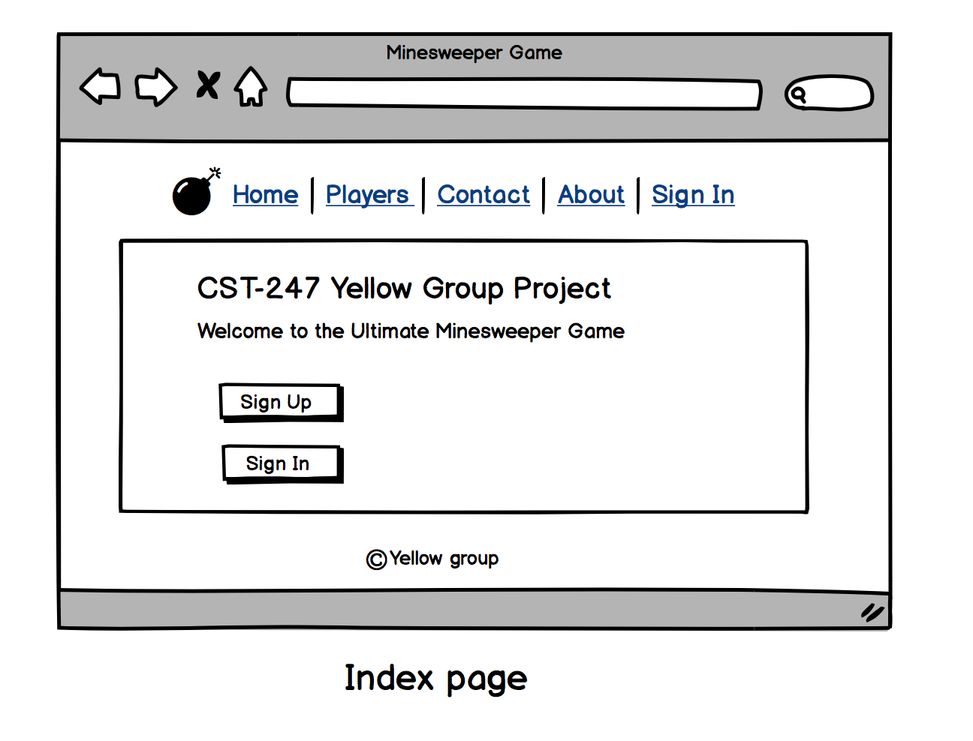

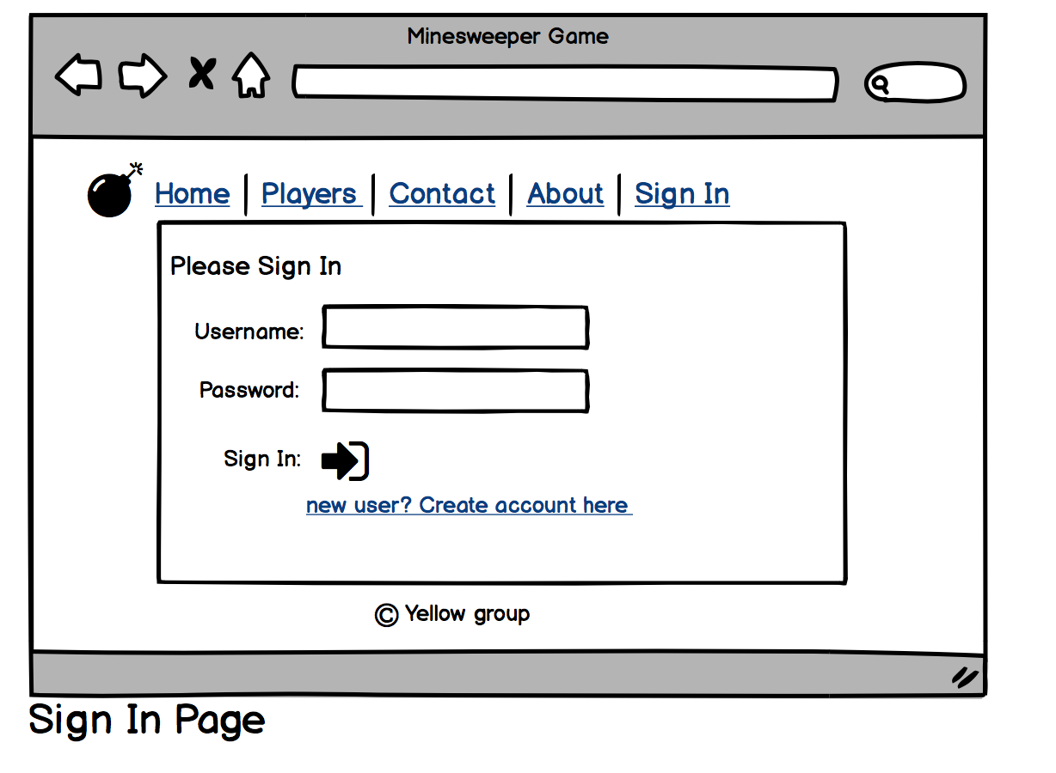

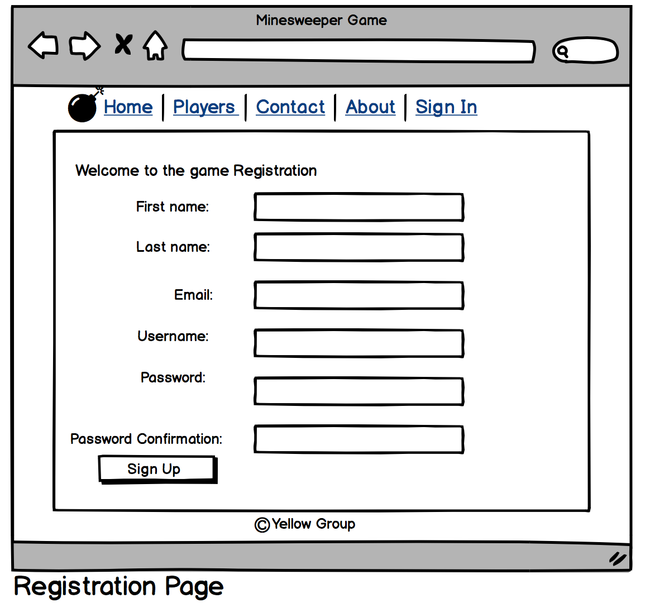

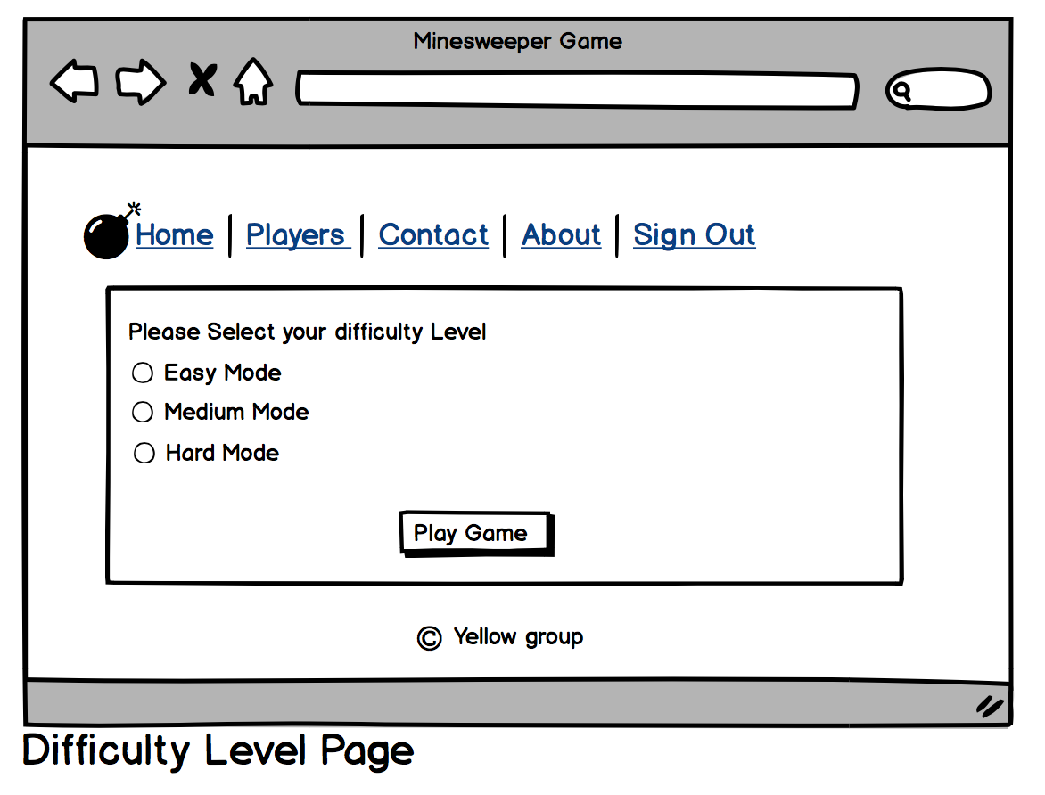

**Class Diagrams:**

*You should insert any class diagrams here. Your class diagrams should be drawn correctly with the three appropriate class compartments, + and – minus to indicate accessibility, and the data types for the state/properties as well as method arguments and return types. If you have no supporting documentation please explain the rational why you are able to leave this section as N/A.*

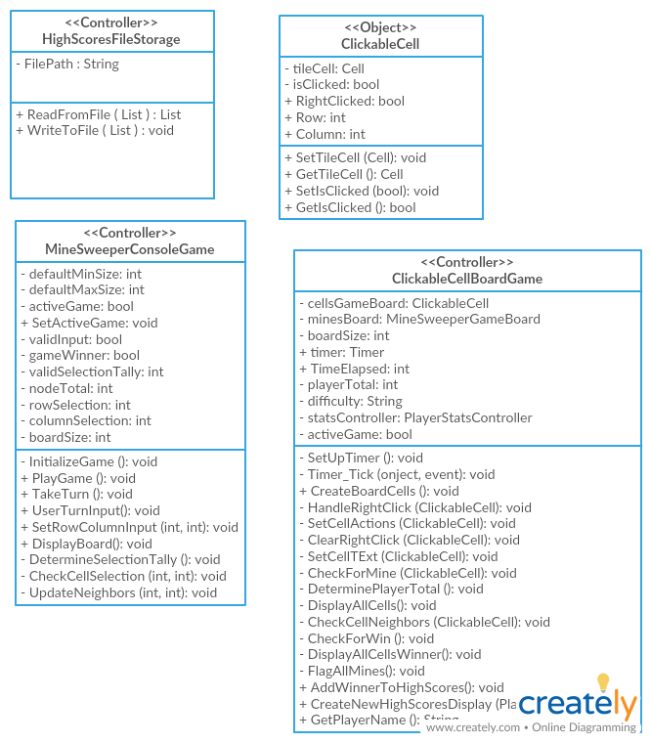

**Pseudo Code:**

*You should provide BitBucket URL references to any code stubs & pseudo code. If you have no supporting documentation please explain the rational why you are able to leave this section as N/A.*

Section Currently Not Applicable.

Code from previous project has no pseudocode and current portions of the project have not yet been undertaken. Refactoring has not yet begun. Pseudocode will fall into place as the project takes wing.

**Other Documentation:**

*You should insert any additional drawings, storyboards, white board pictures, project schedules, tasks lists, etc. that support your approach, design, and project. If you have no supporting documentation please explain the rational why you are able to leave this section as N/A.*

Section Currently Not Applicable.

Do not currently have any additional documentation as the project is still in its design phase.